Oracle BIP – Report Documentation

Document Title: List of Leavers in between the Given dates
Version: 1.0
Date: 15/01/2026
Prepared By: K Kishore
Reviewed By: Supriya Darisa

1. Business Object
Report should fetch the list of Terminated Employees in between given parameter dates.

2. Data Model

2.1 Data Model Name / Path
leavers_report

2.2 SQL / Data Set
SELECT DISTINCT
papf.person_number,
ppnf.first_name,
ppnf.last_name,
ppos.date_start,
ppos.actual_termination_date AS termination_date,
(ppos.actual_termination_date - ppos.date_start) AS days_served,
pjftl.name AS job_name,
hrouftl.name AS dept_name,
pp.phone_number,
pea.email_address,
paam.action_code AS termination_code,
paam.reason_code AS reason_code
FROM per_all_people_f papf
JOIN per_all_assignments_m paam
ON papf.person_id = paam.person_id
JOIN per_person_names_f ppnf
ON papf.person_id = ppnf.person_id
JOIN per_periods_of_service ppos
ON papf.person_id = ppos.person_id
JOIN per_jobs_f_tl pjftl
ON paam.job_id = pjftl.job_id
JOIN hr_organization_units_f_tl hrouftl
ON paam.organization_id = hrouftl.organization_id
LEFT JOIN per_phones pp
ON papf.person_id = pp.person_id
LEFT JOIN per_email_addresses pea
ON papf.person_id = pea.person_id
WHERE ppnf.name_type = 'GLOBAL'
AND ppos.actual_termination_date BETWEEN :p_start_date AND :p_end_date

AND (:p_person_number IS NULL OR papf.person_number = :p_person_number)

AND TRUNC(SYSDATE) BETWEEN papf.effective_start_date AND papf.effective_end_date
AND TRUNC(SYSDATE) BETWEEN paam.effective_start_date AND paam.effective_end_date
AND TRUNC(SYSDATE) BETWEEN ppnf.effective_start_date AND ppnf.effective_end_date

2.3 Parameters (If Any)
Parameter: p_person_number, p_start_date, p_end_date

3. Report

3.1 Report Name / Path
leavers_report_excel

3.2 Output Format(s)
☐ Excel ☐ CSV ☐ XML ☐ PDF ☐ Other: Excel

3.3 Schedule (If Applicable)
☐ Not Scheduled ☐ Scheduled – Frequency: Not Scheduled

4. Template (Optional)

4.1 Template Type
☐ RTF ☐ None (Raw Data Output)

4.2 Template Description
Report must fetch following fields into the report
Person Number
First Name
Last Name
Hire Date
Termination Date
Number of days served for the company
Job Name
Department Name
Home Phone Number
Personal Email address
Termination Action
Termination Reason

5. Sample Output (Optional)

5.1
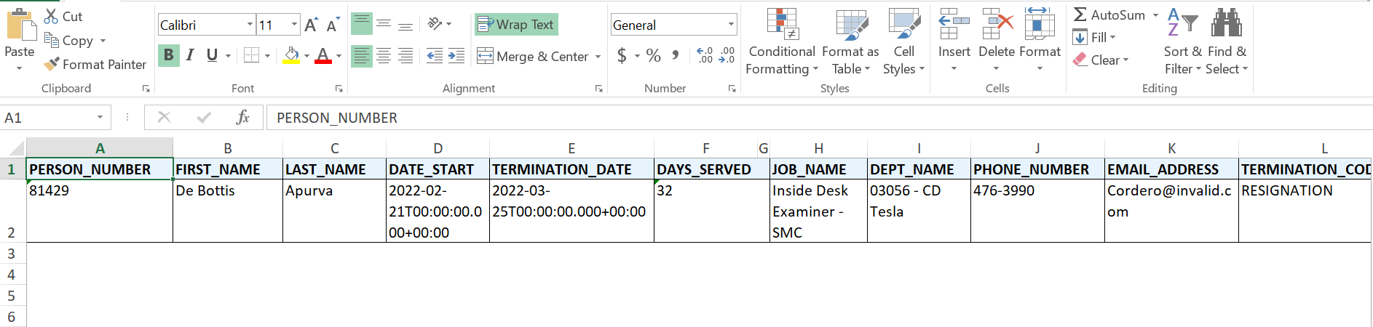
Output format – Excel
5.2
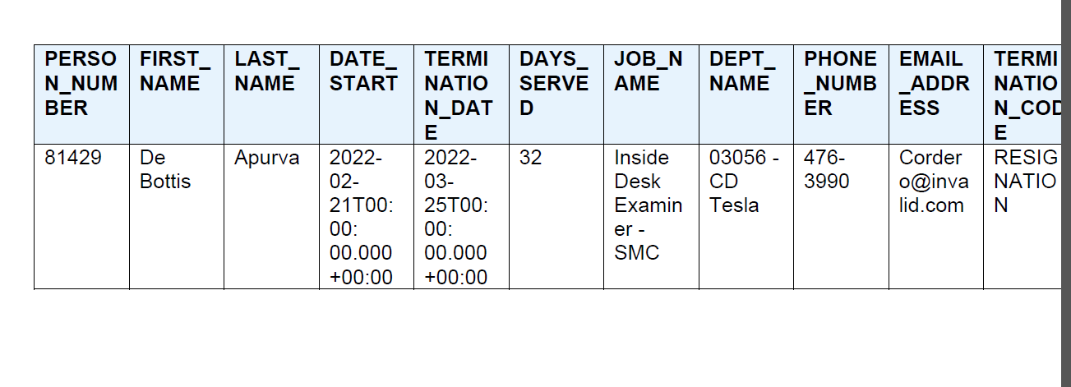
Output format – PDF(RTF Template)

6. Test Cases
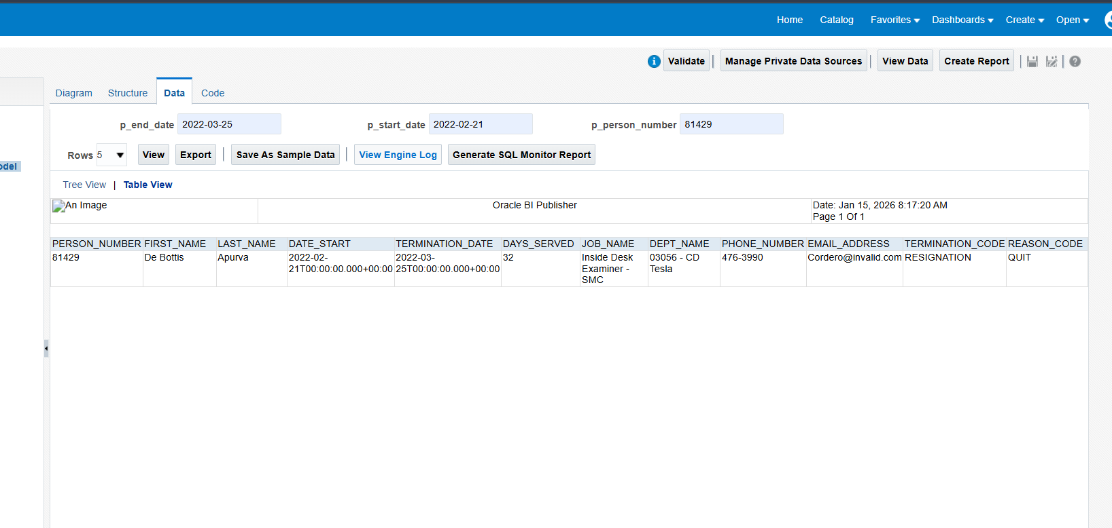
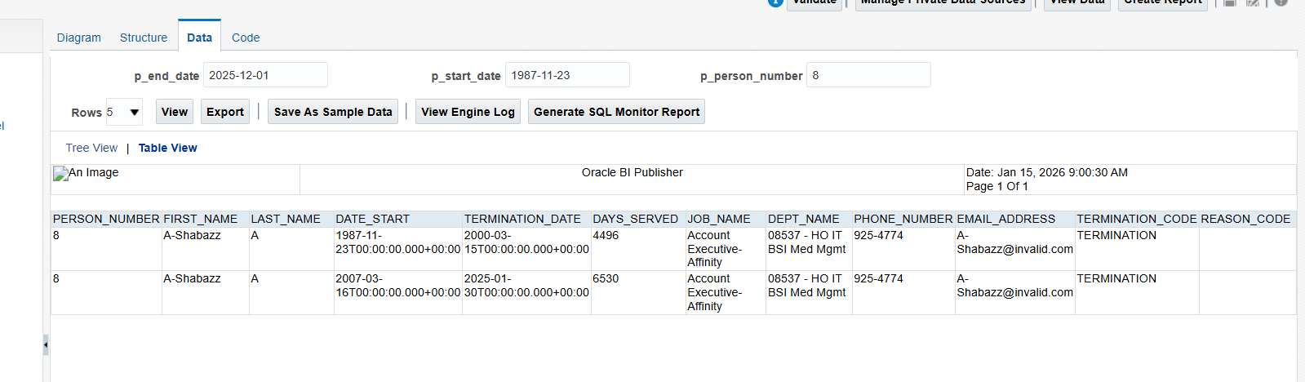
Output – with different Parameteres

